**Chapter 9**

***Transportation & Market Growth***

1800 – 1860, America experienced a **Transportation Revolution**

A period of rapid technological innovations with regards to transportation

Transportation became cheaper and more efficient

Bound the East and the West politically and economically

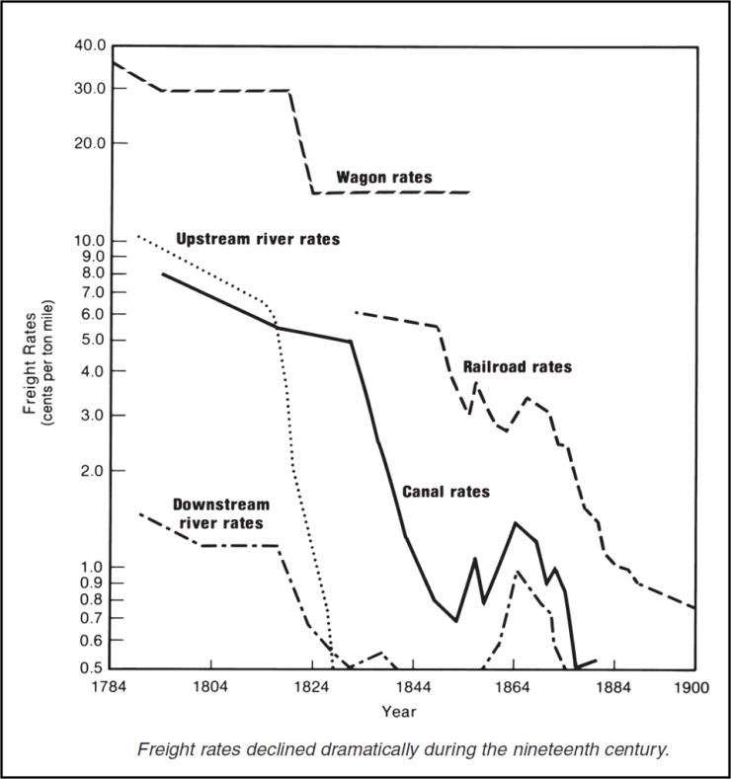

**Inland Freight Rates 1784–1900**

Allowed the development of a national market which

* + - Permitted greater division of labor
    - Enabled people and organizations to engage more in their comparative advantages
    - Led to lower costs because of increasing returns to scale could be taken advantage of in more industries

Many canals, roads, and railroads were built at this time

The federal government paid for only a few of the projects

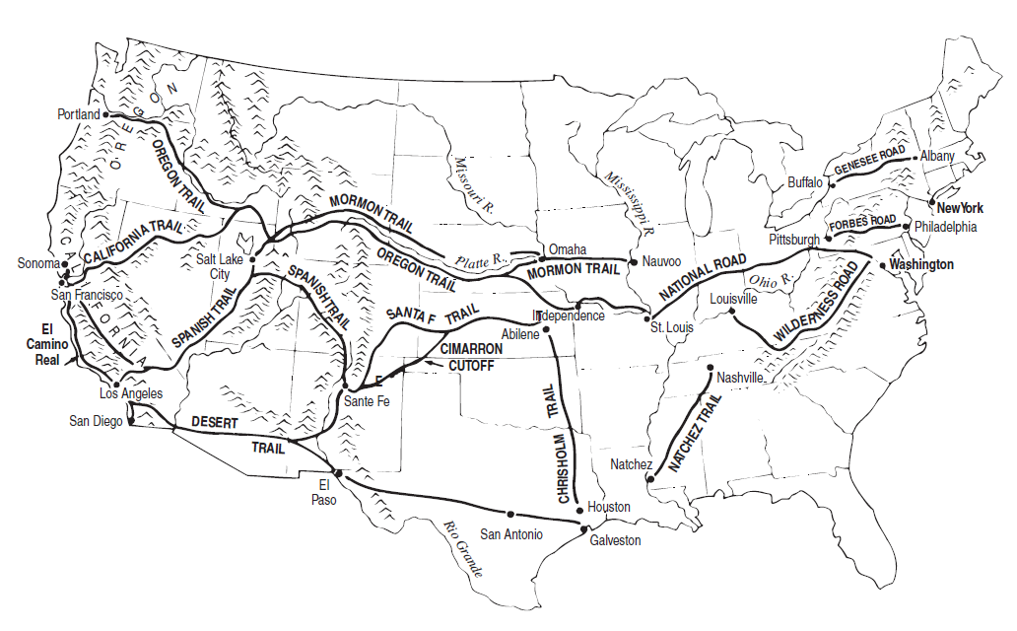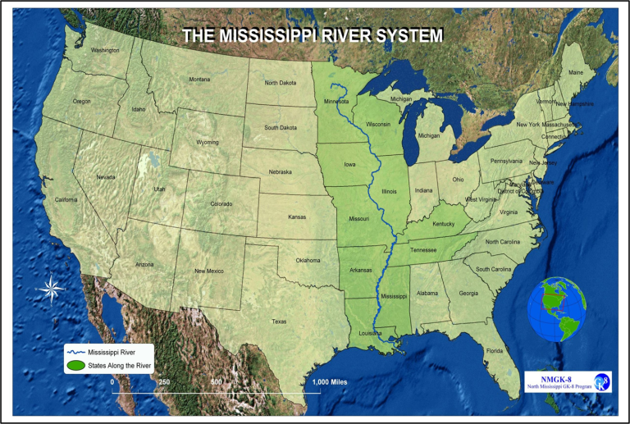Earlier federal plans of transportation expansion ended up being paid for by a mix of state, local and private enterprise

**I. Transportation Innovations**

**Canals**:

* Most of the funding for 19th century American canal building came from state governments
* Primary reason for the demise of the canal system was due to the competition of the railroads
* See pg 44 in Atlas



**Boats as Transportation:**

Created a sharp decline in the costs for domestic freight as the canals and steamboats prevailed

Issues that boats faced as they moved along the waterways included:

* Ice
* Variations in the heights of rivers
* Sand bars
* Sunken ships

Steamboat – Robert Fulton – *“Claremont”*

* + - Used mainly on Mississippi River & along East Coast – not on Great Lakes or high seas
    - Allowed ships to travel upstream against the current of a river
    - Cost-saving innovations from the steamboat were the primary reason for falling transportation costs in the early 1800s
* Dramatic declines in the price of upstream transportation costs and moderate declines in the price of downstream transportation.

|  |  |  |
| --- | --- | --- |
| Average Freight Rates (per 100 lbs of cargo) by Decade between Louisville and New Orleans, 1810-1859 | | |
|  | **Upstream** | **Downstream** |
| Before 1820 | $5.00 | $1.00 |
| 1820-1829 | 1.00 | 0.62 |
| 1830-1839 | 0.50 | 0.50 |
| 1840-1849 | 0.25 | 0.30 |
| 1850-1859 | 0.25 | 0.32 |

* + - Led to an initial decrease in transport costs that continued to fall due to learning by doing and the construction of lighter boats with increased capacity
    - learning to operate the boats at night

Steamboats were substitutes for keelboats and were compliments to flatboats on the Mississippi River

**Claremont**

**Flat Boat**

**Keel Boat**

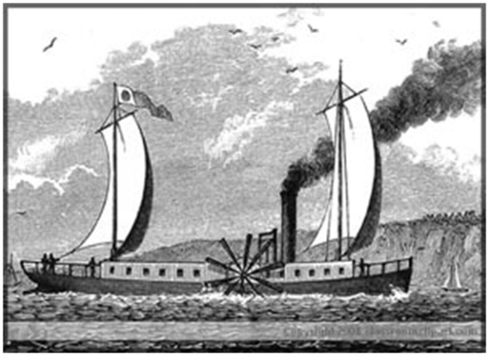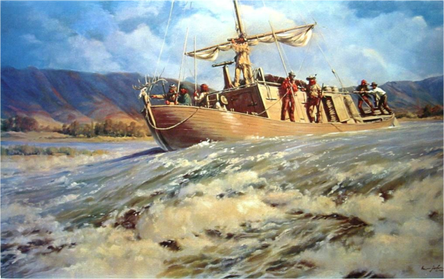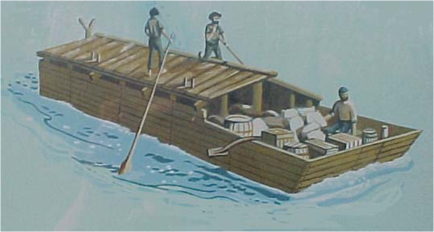

**Ocean Transport**

* 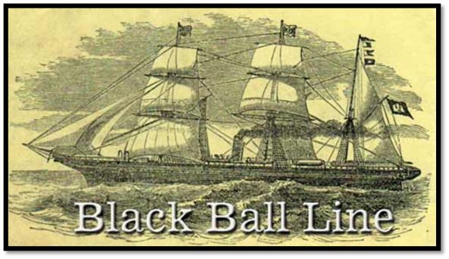Black Ball Line (1818)

NYC to Liverpool, England

Would sail whether full or not

* Yankee Clippers - French Design

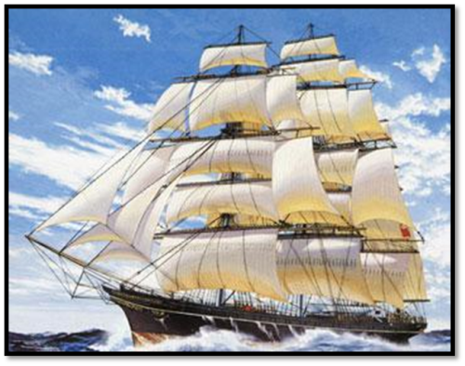

* Technological Improvements:
  + - * + Steam engines
        + Iron & steel hulls
        + Archimedes screws instead of paddlewheel
* Sailing ships continued to dominate ocean-going vessels up to 1860

**Railroads - Iron Horse(Steam-powered):**

* 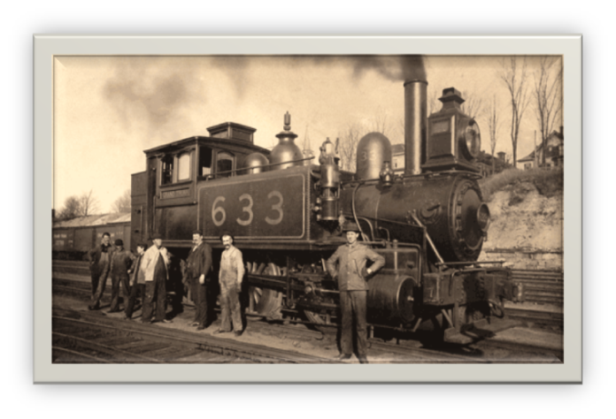A steam railroad locomotive. This term was used when comparing early railroad to slower, less powerful methods of transportation.
* Page 45 of Atlas
  + - Early RR in Baltimore 1828 – 13 miles of track
    - Privately financed in 1st half of 19th Century
    - Between 1830 and 1860 the number of miles of railroad in operation increased by over 1000%

|  |  |
| --- | --- |
| Miles of Railroad In Operation, 1830-1860 | |
| Year | **Mileage** |
| 1830 | 23 |
| 1835 | 1,098 |
| 1840 | 2,818 |
| 1845 | 4,623 |
| 1850 | 9,021 |
| 1855 | 18,374 |
| 1860 | 30,626 |

* + - Problem of universal gauge of track until 1885 - *“Stephenson Gauge = 4 ¾ ‘ wide”*
    - Increase in productivity of the railroads doubled in the 20 years prior to the Civil War and was due to:
    - standardization of the gauge of railroad tracks
    - increased size of railroad cars
    - increased use of existing capital

**Roads**

* The Western region tended to support federal construction of a system of roads in the 19th century
* It was difficult for the Federal Government to build a highway system before the Civil War was because of the rivalries among the different sections of the country which stalled legislation
* Private turnpikes were an alternative method of raising money but had problems because
* 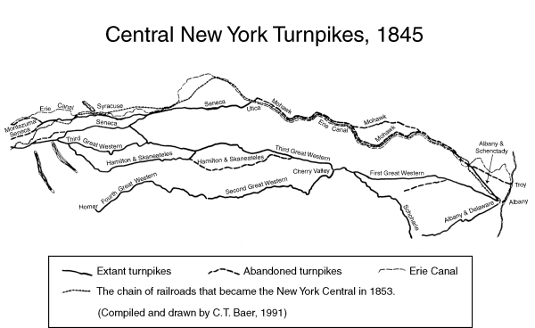tolls were easily avoided
* it was too costly to carry freight by land carriage
* they faced extensive competition from steamboats, canals and railroads
* dishonest gatekeepers often pocketed the tolls collected
  + - *Wilderness Road* 
      * From VA to TN to KY
      * Used by settlers to reach Kentucky
      * Blazed by Daniel Boone
* *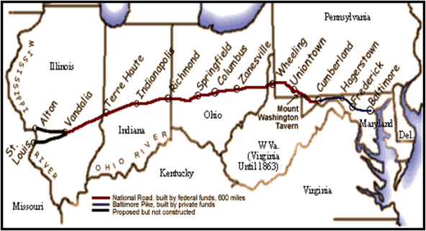National Road*

*(Also called the Cumberland Road)*

* + - * Was the most notable surfaced road of the 19th century
      * America's first partially federally funded interstate highway
      * From Cumberland, Maryland to Vandalia, Illinois
      * Approximately 620 miles long
      * Provided a route to the Western part of the country
      * Later extended to St. Louis, MO

**II. Three (3) Gateways of Western Commerce:**

* ***Southern Gateway*:** Mississippi River – New Orleans

The Southern Gateway was primarily a water-based route

The leading transport route in the US (in terms of volume of freight from the West)

Dominant gateway until 1840’s

* ***Northern Gateway*:** Chicago – Great Lakes – Erie Canal – Hudson River – NYC

Connected Pittsburgh to Philadelphia and Wheeling to Baltimore

Included the **Erie Canal – *DeWitt Clinton***

* + - * From Buffalo to Albany, NY
      * Financed by NY State Bond issue of $7 million and by the federal government
      * Most successful & profitable of American canals
        + Earned the highest rate of return on investment
        + The most important canal in terms of the number and dollar value of shipments
      * Changed the flow of western commerce from Southern Gateway to Northern Gateway
      * Transformed NYC into a boomtown
      * NYC - America’s #1 salt water port
      * Chicago - America’s #1 freshwater port

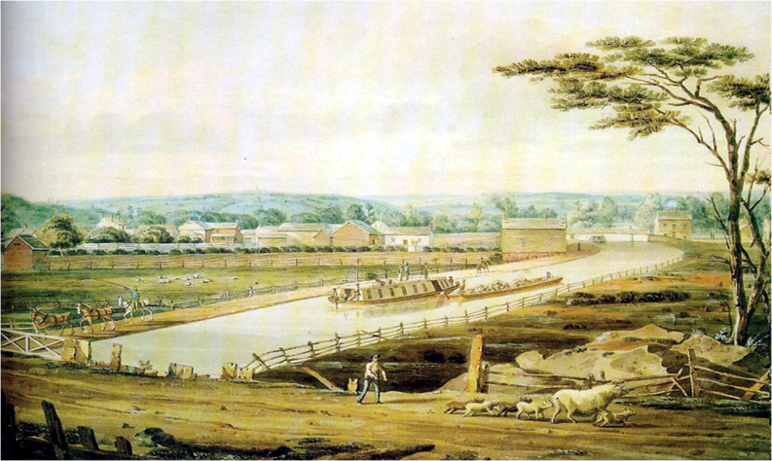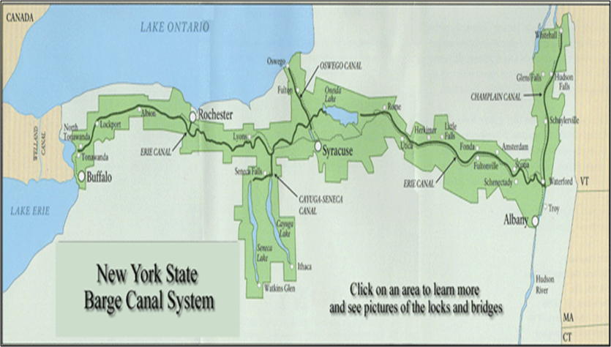

ERIE CANAL

* ***Northeast:*** *Pittsburgh – Baltimore*

National Road, Toll Roads, RR’s